1. Complete Software Requirements Specification (SRS) Document

1. Introduction

1.1 Purpose
This document defines the functional and non-functional requirements for the Restaurant Mobile Application MVP. It provides a clear blueprint for stakeholders, developers, and evaluators to understand the core design, state architecture, and UI navigation flow.

1.2 Project Scope
The app is a cross-platform mobile app built using React Native and Expo. It allows users to:
- Authenticate using local user states.
- Browse menu items filtered by category or search terms.
- View detailed food item descriptions, nutritional tags, and ingredient lists.
- Manage dynamic cart items with real-time price, discount, and fee updates.
- Book table reservations.
- Switch dynamically between Light Mode and Dark Mode themes.

2. Overall Description

2.1 System Architecture
The application runs as a modular client-side app utilizing React's Context API (AuthContext, CartContext, ThemeContext) for global state management and useReducer (cartReducer.js) for complex action dispatches (adding items, applying promo codes, quantity adjustments).

2.2 User Persona
- Customer: End-user who views restaurant menus, places orders, applies discounts, toggles themes, and manages reservations.

3. Detailed Requirements

3.1 Functional Requirements (FR)
- FR-1 (Auth): User can log in with demo credentials stored in users.js.
- FR-2 (Menu): Displays items from menu.js categorized dynamically (Fast Food, Drinks, Desserts, etc.).
- FR-3 (Search & Filter): Real-time text search and active category pill selection.
- FR-4 (Cart Logic): Dynamic calculation of subtotal, percentage discounts (WELCOME10, FEAST20), fixed delivery fees, and grand total.
- FR-5 (Table Reservation): Selection of seating capacity from tables.js and date/time selection.
- FR-6 (Theme Toggle): Instant app-wide color scheme updates powered by ThemeContext and useThemeColor.

3.2 Non-Functional Requirements (NFR)
- NFR-1 (Performance): 60 FPS transitions via React Navigation (Stack and Bottom Tabs).
- NFR-2 (Maintainability): Reusable design primitives (Button, Card, Header, MenuItemCard) kept separate from business/screen logic.
- NFR-3 (Usability): Dark and light mode visual contrast conforming to accessibility standards.

2. Complete Viva Preparation & Question Guide

Q1: How did you design and implement the state management?
Answer: "We used React's native Context API combined with useReducer to avoid external library overhead while keeping code clean. We separated global concerns into three main contexts: AuthContext for user login session, ThemeContext for central color styling, and CartContext powered by a cartReducer to manage complex cart updates like incrementing, decrementing, and promo code applications."

Q2: Why use useReducer instead of useState for the Cart?
Answer: "The cart has complex state transitions where multiple sub-properties (items array, total count, promo codes, error states, dynamic discounts) depend on single actions. useReducer consolidates all these mutations into a single pure function (cartReducer), making actions like ADD_ITEM, APPLY_PROMO, and REMOVE_ITEM predictable and easy to debug."

Q3: How does the dynamic Theme system work across components?
Answer: "We created a centralized theme.js containing color definitions for both Light and Dark modes. ThemeContext manages the current active mode, while a custom hook useThemeColor provides easy access to the active color palette. Reusable components simply import useThemeColor() and dynamically style their backgrounds, borders, and typography."

Q4: What is the structure of your navigation layout?
Answer: "We used @react-navigation/native-stack combined with @react-navigation/bottom-tabs. The root stack navigator switches between unauthenticated screens (LoginScreen) and authenticated flows (MainTabs). MainTabs wraps MenuScreen, ReservationScreen, CartScreen, and ProfileScreen, while secondary screens like ItemDetailScreen and CheckoutScreen push onto the stack.

3. ULM

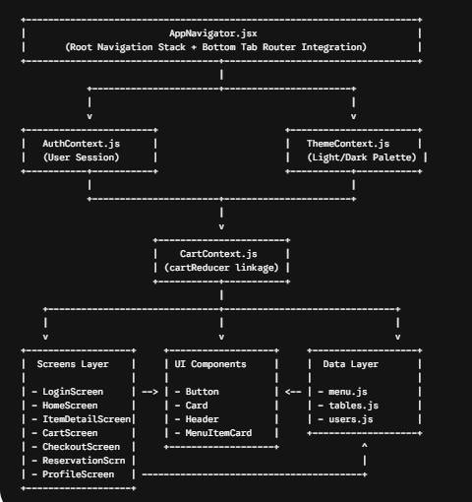

UML Sequence Diagram: Order & Checkout Flow

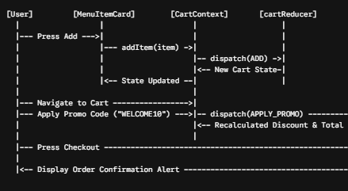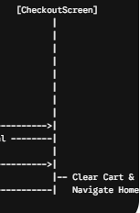

UML State Diagram : Cart Operations

